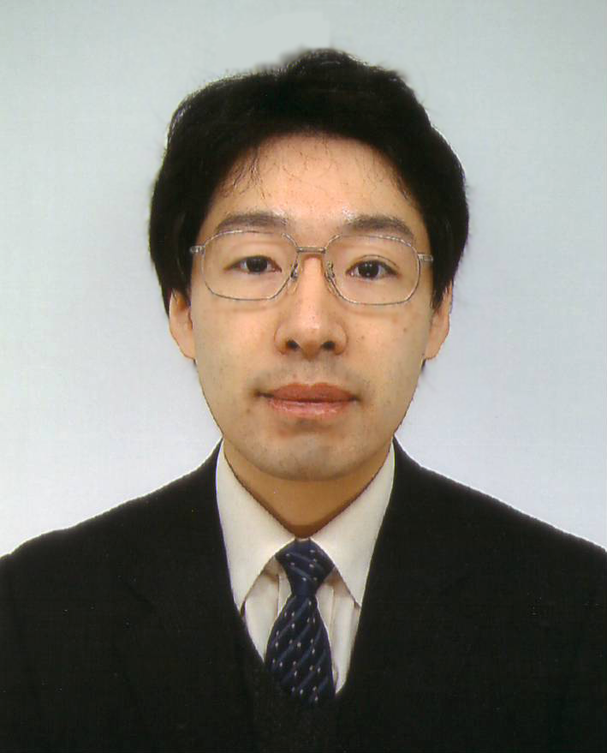 | Name | Masaya Matsuoka | Nationality | Japan
 | Afiliation | Osaka Prefecture University | Position | Professor
 | Telephone | +81-72-254-9288 | Faxmile | +81-72-254-9910
E-mail | matsumac@chem.osakafu-u.ac.jp |  | Mobile Phone | +81-90-7091-9615
Mail address | 1-1 Gakuen-cho, Sakai, Osaka 599-8531, Japan
Education | 1997: Doctorate, Graduate School of Engineering, Osaka Prefecture University
Experience | 1998 - Research Associate at Osaka Prefecture University  2004 - Lecturer at Osaka Prefecture University  2007 - Associate Professor at Osaka Prefecture University  2010 - Professor at Osaka Prefecture University
Main  Scientific  Publication | [1] J. Schneider, M. Matsuoka, M. Takeuchi, J. Zhang, Y. Horiuchi, M. Anpo, D.W. Bahnemann, "Understanding TiO₂ Photocatalysis: Mechanisms and Materials",  Chem. Rev., 114, 9919-9986 (2014).  [2] T. Toyao, M. Saito, S. Dohshi, K. Mochizuki, M. Iwata, H. Higashimura, Y. Horiuchi, M. Matsuoka, "Development of a Ru complex-incorporated MOF photocatalyst for hydrogen production under visible-light irradiation", Chem. Commun., 50, 6779-6781 (2014).  [3] T. Toyao, J. Morishima, M. Saito, Y. Horiuchi, T. Kamegawa, G. Martra, S. Coluccia, M. Matsuoka, M. Anpo, "FT-IR study of the reaction mechanisms for photocatalytic reduction of NO with CO promoted by various single-site photocatalysts", J. Catal., 299, 232-239 (2013).  [4] Y. Horiuchi, T. Toyao, M. Saito, K. Mochizuki, M. Iwata, H. Higashimura, M. Anpo, M. Matsuoka, "Visible-Light-Promoted Photocatalytic Hydrogen Production by Using an Amino-Functionalized Ti(IV) Metal-Organic Framework", J. Phys. Chem. C, 116, 20848-20853 (2012).  [5] T. Kamegawa, M. Saito, T. Watanabe, K. Uchihara, M. Kondo, M. Matsuoka, M. Anpo, "Preparation of inorganic-organic hybrid mesoporous material incorporating organoruthenium complexes and its application as a heterogeneous catalyst"  J. Mater. Chem., 21, 12228-12231 (2011).

